Hi

I need to create a software that manipulates a decryption of files (the software will actually will not do anything. We need to use it for video purposes only)

We have software that we use to decrypt the files however for the purpose of youtube videos we do not want to show our competitors the software we use

An example of what we want to achieve can be seen here https://www.youtube.com/watch?v=Zj_r5sX95qM

The software will need to look like this (just as an example)

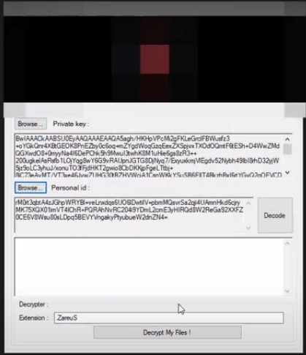

|  |
| --- |
| FDR Decryption v2.3 |
|  |
| Private Key: |
| Extension: |
| ID: |
| Output    [DECRYPT] C:\users\admin\desktop\script.id[1234].[gotya@protonmail.com].EIGHT  [DECRYPT] C:\users\admin\desktop\abc.id[1234].[gotya@protonmail.com].EIGHT  Etc… |



Explanation:

1. When you click on Browse, I should be able to select a text file – the software needs to read the content of the file and display it under the private key box
2. Extension is a text box field. I will enter details there manually
3. ID is a text box field. I will enter details there manually
4. When I click Decrypt My Files! I need a password box so I can enter a passcode (9755) so no one can use the tool without the password.  
   once the password is entered, The following should happen on the output box
   1. Display a warning message

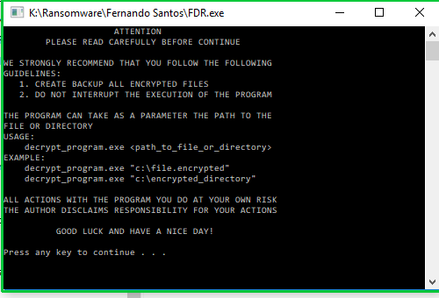  
I will alter the text slightly later on. It needs to more of a windows pop GUI

* 1. search on the computer to display all the files on the computer with the ID and extension combination entered by me. The results will be displayed on the output box  
       
     for example, if the ID is 1234 and the extension of the files is EIGHT (like the example below)  
     
  2. The output box should search and display a list of all the files on the computer with the *1234*.EIGHT
  3. Add a text at the start or at the end of the search saying [DECRYPT]
  4. After all the files are listed on the text box it should say   
     Decryption Completed.

I should be able to scroll up and down on the output box as there will be a lot of files displayed

The tool is not decrypting anything beside listing the file and amending a text [DECRYPT]

We need to make sure our competitors don’t see the tools we use

I want to make sure the software has a GUI interface without showing any reference to the coding language behind it

It needs to be a small executable program (click and run)